**SYNOPSIS OF JS PROJECT “WEATHER-APP”**

**INTRODUCTION**

The Weather App is a web-based application that allows users to retrieve real-time weather information for a specific location. It is built using HTML, CSS, and JavaScript, and utilizes a weather API to fetch and display weather data. The application provides a user-friendly interface that allows users to easily search for weather information of any desired location, and view current weather conditions as well as weather forecasts for upcoming days.

The Weather App is designed to be responsive, ensuring that it can be accessed and used seamlessly across various devices, including desktops, tablets, and mobile phones. With its intuitive and visually appealing interface, the Weather App aims to provide a convenient and reliable source of weather information for users to plan their activities and stay informed about the weather conditions of their desired location.

**KEY FEATURES:**

* Location Search: Users can enter a city name or ZIP code in a search bar to search for weather information of a specific location.
* Weather Display: The application displays the current weather conditions of the searched location, including temperature, weather description, humidity, wind speed, and other relevant information.
* Forecast Display: Users can view the weather forecast for the upcoming days, including temperature, weather description, and date.
* Responsive Design: The Weather App is designed to be responsive, ensuring a seamless user experience across different devices.

the Weather App aims to provide an efficient and user-friendly solution for accessing real-time weather information, helping users plan their activities and stay informed about the weather conditions of their desired location.

**TECHNOLOGY USED**

The Weather App is developed using several key technologies, including HTML, CSS, and JavaScript, to create a dynamic and interactive web-based application.

HTML (Hypertext Markup Language) is used to structure the content and layout of the Weather App, defining elements such as headings, paragraphs, buttons, forms, and images. It provides the foundation for creating the user interface and displaying the weather information in a structured and organized manner.

CSS (Cascading Style Sheets) is used to style the Weather App, defining the visual appearance and layout of the application. It is responsible for setting the fonts, colors, spacing, and other visual elements that contribute to the overall look and feel of the app. CSS also enables responsive design, ensuring that the app adapts to different screen sizes and devices.

JavaScript is used to add interactivity and dynamic functionality to the Weather App. It is responsible for fetching weather data from the weather API, processing the data, and updating the user interface with the retrieved weather information. JavaScript also handles user interactions, such as search functionality, displaying weather forecasts, and updating the UI in real-time.

The Weather App is developed using HTML, CSS, and JavaScript to create a visually appealing and interactive web application that provides real-time weather information in a user-friendly manner. These technologies work together to enable the app to fetch, process, and display weather data, and provide a seamless and responsive user experience.

**HARDWARE AND SOFTWARE REQUIREMENTS**

The Weather App is a web-based application that runs on commonly available hardware and software. Here are the general hardware and software requirements for running the Weather App:

Hardware Requirements:

Computer or mobile device: The Weather App can be accessed on a desktop computer, laptop, tablet, or mobile device with internet connectivity.

Internet connection: The Weather App requires an active internet connection to fetch real-time weather data from the weather API.

Software Requirements:

Web browser: The Weather App is designed to run on modern web browsers such as Google Chrome, Mozilla Firefox, Safari, or Microsoft Edge. The browser should be updated to the latest version for optimal performance.

Text editor: A text editor is needed for modifying the HTML, CSS, and JavaScript code of the Weather App during development. Popular text editors include Visual Studio Code, Sublime Text, or Atom.

Code editor: A code editor is needed for writing, debugging, and testing the JavaScript code of the Weather App. Popular code editors for JavaScript development include Visual Studio Code, Sublime Text, or Atom.

Internet access: The Weather App requires internet access to fetch real-time weather data from the weather API. A stable and reliable internet connection is recommended for smooth operation.

Note: The specific hardware and software requirements may vary depending on the implementation and hosting environment of the Weather App, such as the hosting platform (e.g., local development environment or web server), backend technologies used (e.g., server-side scripting), and any additional dependencies or libraries used in the application. It's always recommended to refer to the documentation or requirements provided with the Weather App's source code or hosting environment for any specific hardware or software requirements.

**SCREENSHOTS**

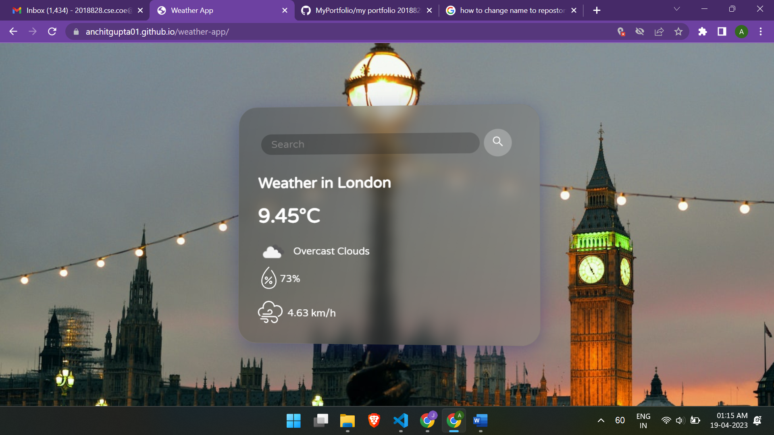

**CONCLUSION**

In conclusion, the Weather App is a web-based application that utilizes HTML, CSS, and JavaScript technologies to provide real-time weather information to users. It offers a user-friendly interface that allows users to input their location or search for a specific location to retrieve weather data such as temperature, humidity, wind speed, and weather condition. The app is designed to be responsive and can be accessed on various devices, including desktop computers, laptops, tablets, and mobile devices.

Through the use of HTML, CSS, and JavaScript, the Weather App offers a visually appealing and interactive experience for users to quickly obtain weather information for their desired location. The app fetches data from a weather API, which provides accurate and up-to-date weather data. Users can also customize the app's appearance and behavior through CSS styles and JavaScript functionalities.

The Weather App serves as a practical and informative tool for users to stay updated with the latest weather conditions in their area or any other location of interest. It demonstrates the power and flexibility of web technologies in creating dynamic and interactive applications. Whether it's checking the weather before heading out for the day, planning outdoor activities, or staying informed about weather changes, the Weather App provides a valuable service to users worldwide.

Overall, the Weather App showcases the use of HTML, CSS, and JavaScript to create a functional and visually appealing web application that enhances the user's experience in accessing weather information. It serves as an example of how these technologies can be used to develop interactive and informative web applications for various purposes.